~ SALE REPORT ~
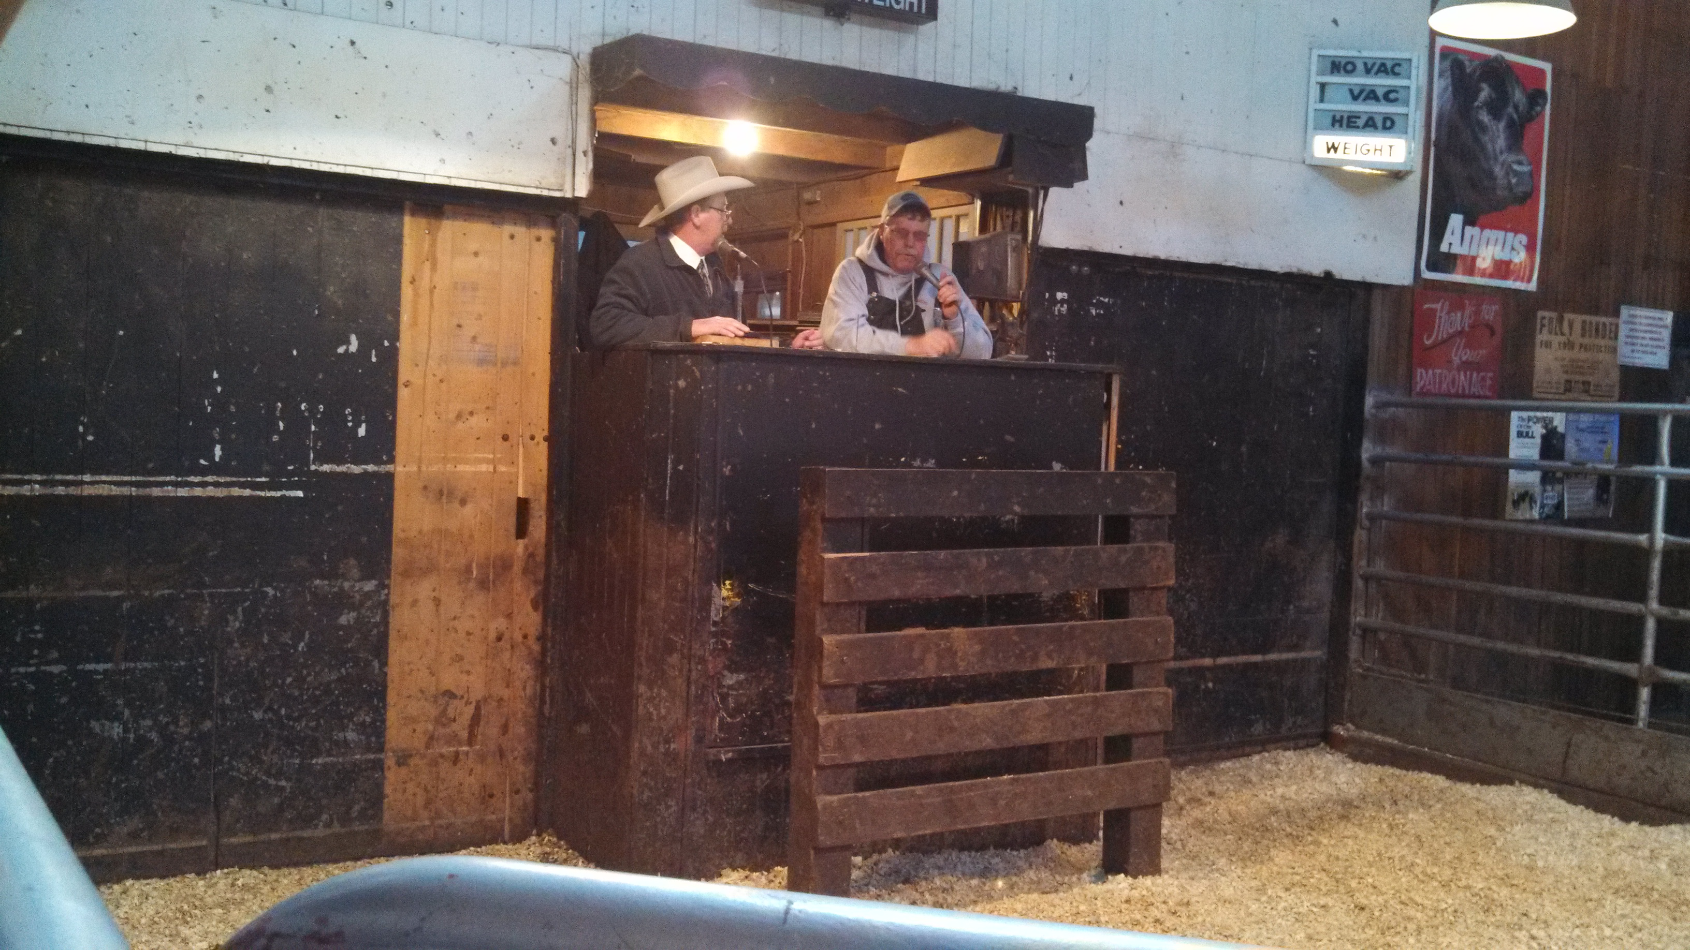

WEEKS ANGUS FARM PRODUCTION SALE
March 8, 2014 Winterset, IA

GROSS: $138,000 31 Bulls Avg $3645
16 Open Heifers Avg $1563

TOP BULLS:
Lot 12 - $6100 WAF Right Answer 330
A 2-8-13 son of Connealy Right Answer 746. Sold to Clell Looney, Lenox, IA.

Lot 15 - $6000 WAF Hoover Dam 334
A 2-11-13 son of Hoover Dam. Sold to Oswald Ranch, Osceola, IA.

Lot 29 - $5300 WAF Final Answer 332
A 2-28-13 son of LaGrand Final Answer 9065. Sold to David Robinson, Winterset, IA.

Lot 14 - $5100 WAF Aberdeen 329
A 2-11-13 son of TC Aberdeen 759. Sold to David Robinson, Winterset, IA.

TOP OPEN HEIFERS:
Lot 35 - $1700 WAF Oakleaf W322
A 2-1-13 daughter of Connealy Right Answer 746. Sold to Dennis Faust, Dexter, IA.

Lot 37 - $1700 WAF Blueblood Lady W313
A 2-3-13 daughter of Mytty In Focus. Sold to Dennis Faust, Dexter, IA.

Lot 44 - $1700 WAF Queen Alice W321
A 2-19-13 daughter of LaGrand Bismarck 0084. Sold to Craig Petersen, St Charles, IA.

Auctioneer: Pete Myers

Sale Manager: Conover Auction Service Inc., Al & Jeanne Conover, Baxter, IA

