~ SALE REPORT ~
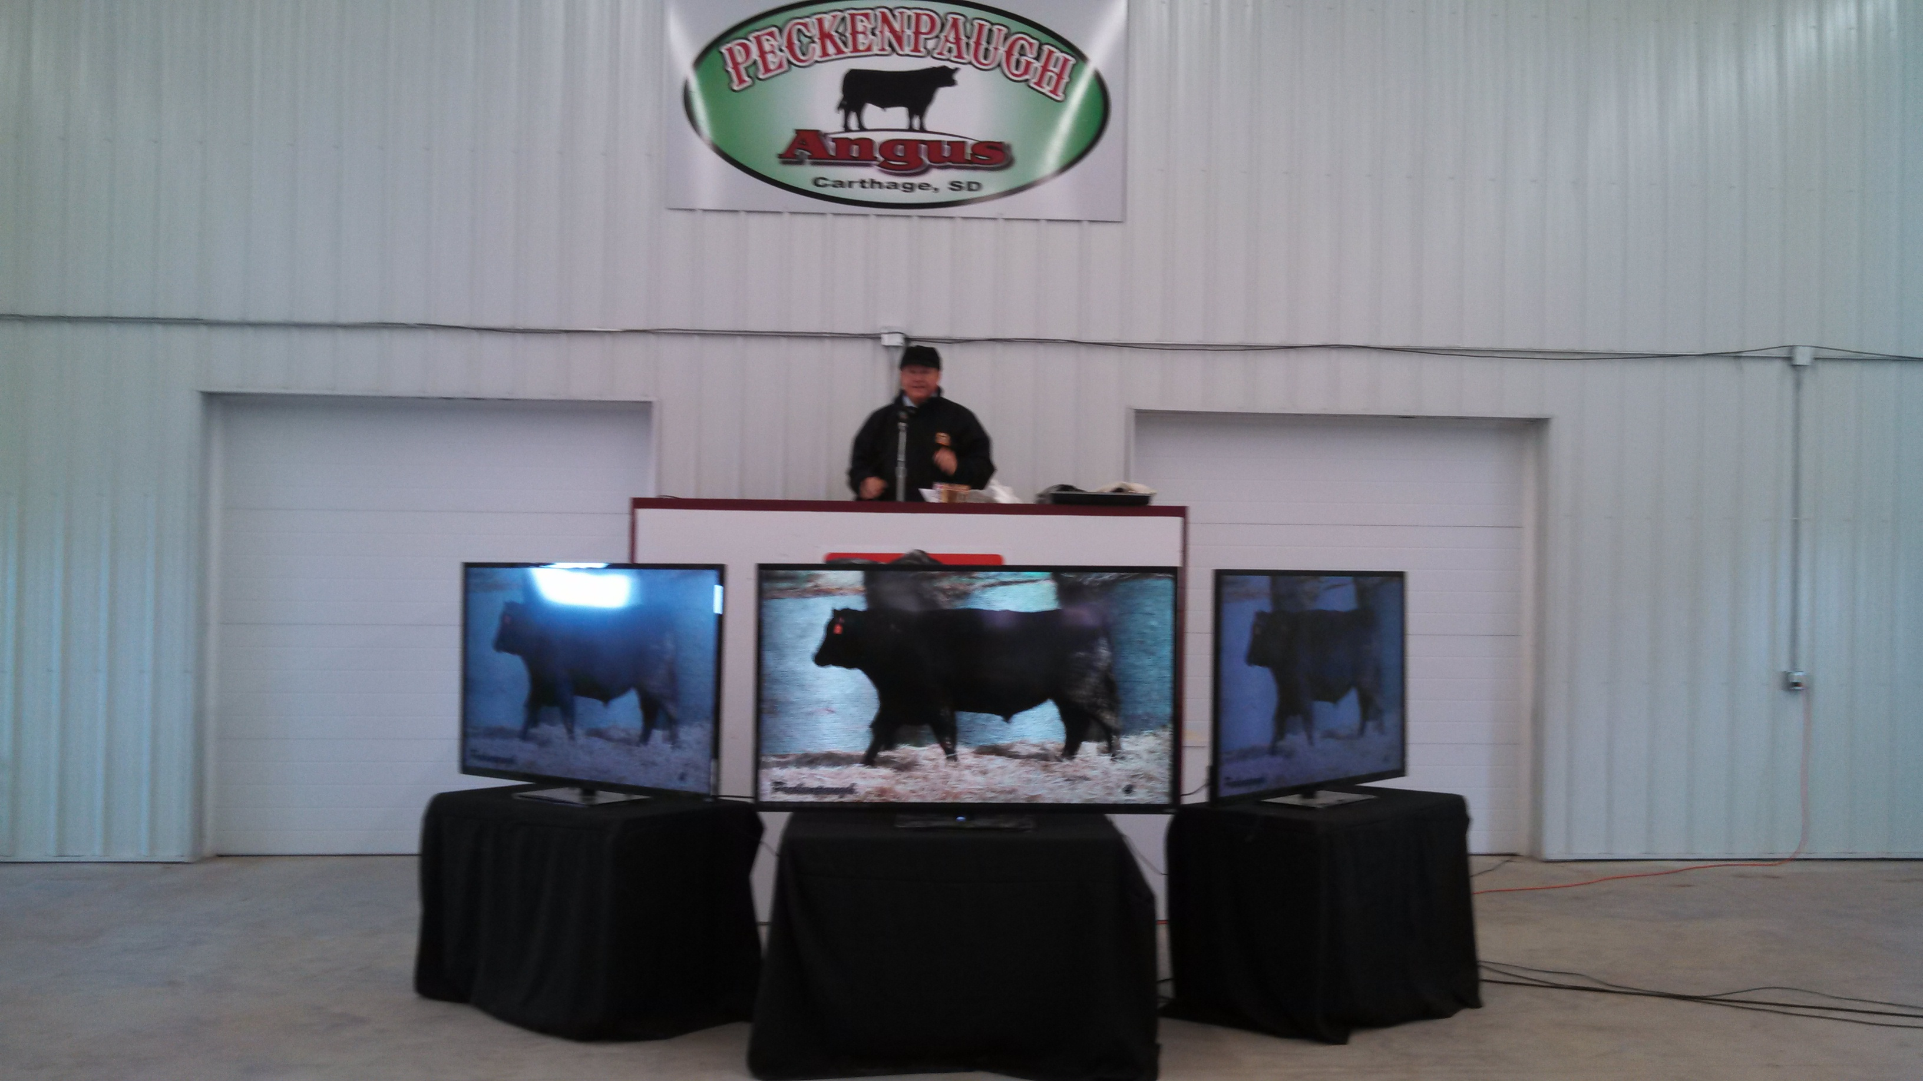

PECKENPAUGH ANGUS BULL SALE
Carthage, SD March 5, 2014

GROSS: $201,850
39 Bulls Avg $4404
16 Commercial Bred Heifers Avg $1881

TOP BULLS:
Lot 34 - $8000 Pecks 5050 267
A 3-22-12 son of GAR New Design 5050. Sold to Jeffrey Hinker, Forestburg, SD.

Lot 7 - $8000 Pecks Extra 4X13 213
A 2-25-12 son of Sinclair Extra 4X13. Sold to Peckenpaugh Ranch, Carthage, SD.

Lot 15 - $7000 Pecks Net Worth 229
A 3-5-12 son of SAV Net Worth 4200. Sold to Tom Peckenpaugh, DeSmet, SD.

Lot 20 - $7000 Pecks Genetics by Design 240
A 3-8-12 son of Genetics by Design 049. Sold to Peckenpaugh Ranch, Carthage, SD.

Lot 25 - $7000 Pecks CC&7 H421 250
A 3-15-12 son of Hoover CC&7 H421. Sold to Peckenpaugh Ranch, Carthage, SD.

Lot 3 - $6500 Pecks CC&7 H421 205
A 2-19-12 son of Hoover CC&7 H421. Sold to Robert Person, Hartford, SD.

Lot 10 - $6000 Pecks 5050 221
A 2-29-12 son of GAR New Design 5050. Sold to Jeffrey Hinker, Forestburg, SD.

Auctioneer: Col. Al Conover, Baxter, IA

Sale Manager: Conover Auction Service Inc., Al & Jeanne Conover, Baxter, IA

