~ SALE REPORT ~

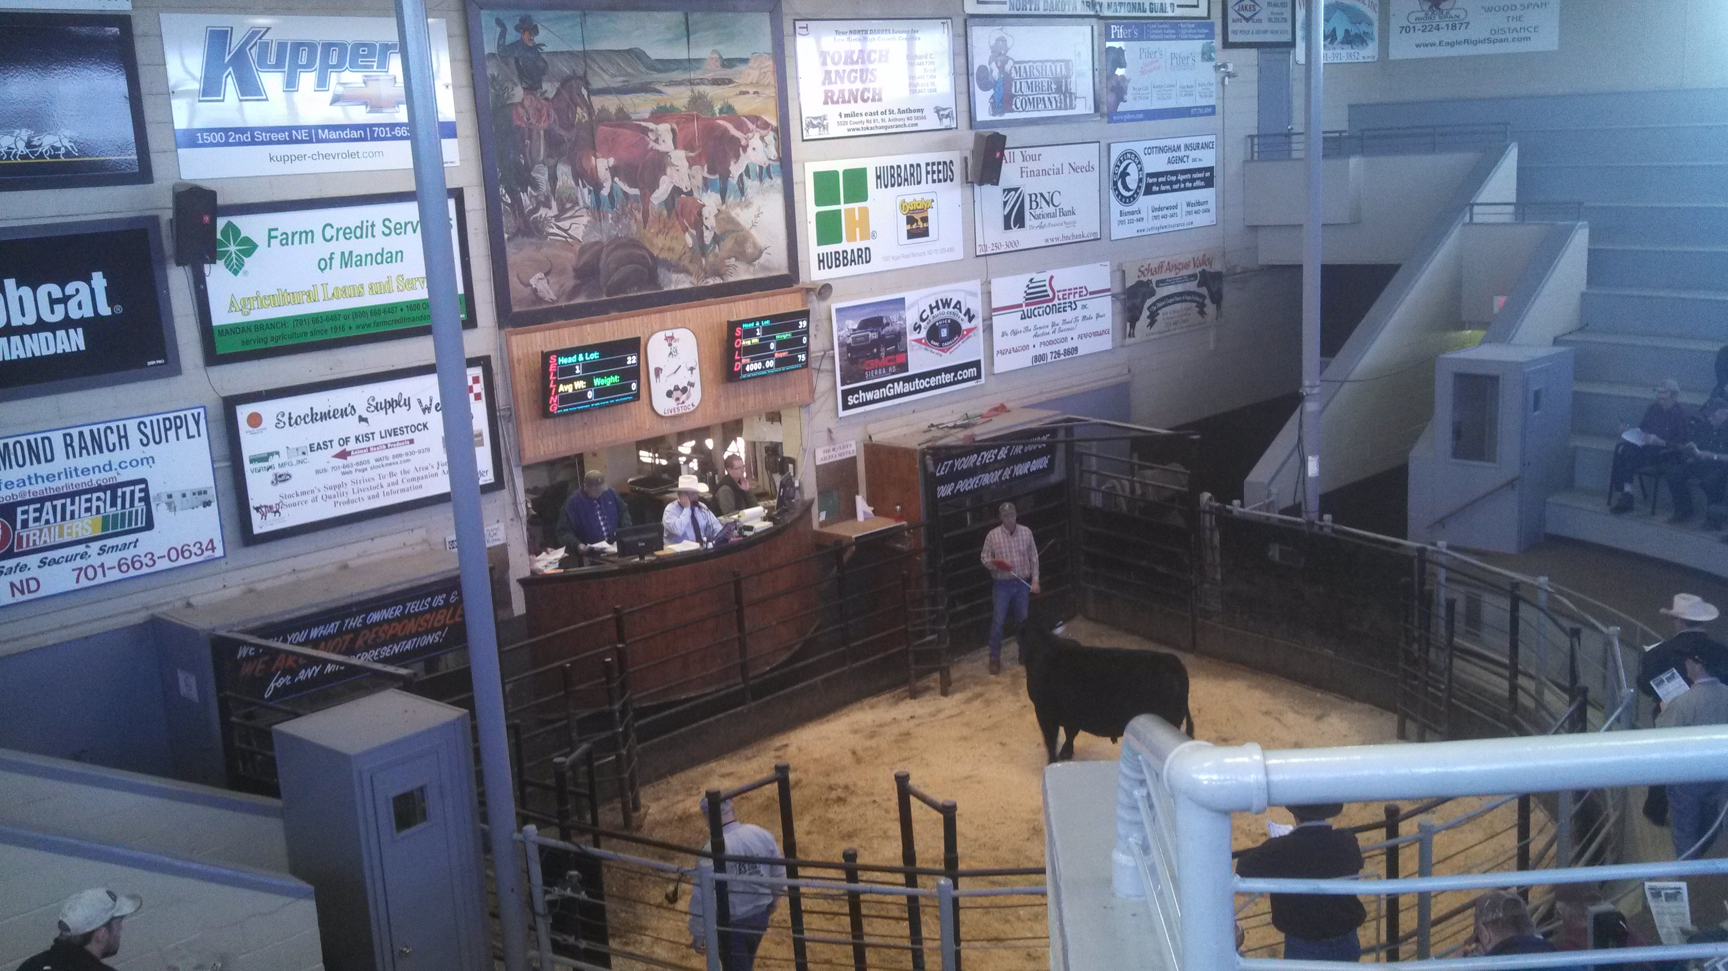
Josephson Angus & Haugen Cattle Co.
Annual Bull Sale
Mandan, ND April 10, 2014

SALE GROSS: $226,250

54 Bulls Avg $4190

TOP SELLLING BULLS:
Lot 42 - $8000 HCC Confidence 3321
1-22-13 son of Connealy Confidence 0100. Sold to Justin Duttenhefner, Dodge, ND

Lot 1 - $8000 HCC Upward 3126
A 2-2-13 son of Sitz Upward 307R. Sold to Garrett Nelson, Mandan, ND

Lot 20 - $7000 HCC Consensus 3187
A 2-3-13 son of Connealy Consensus 7299. Sold to David Opp, Hebron, ND

Lot 15 - $6750 HCC Timeless 3119
A 2-2-13 son of WMR Timeless 458. Sold to Brandon Mueller & DJ Morast, Dazey, ND

Lot 3 - $6000 HCC Upward 3897
A 2-1-13 son of Sitz Upward 307R. Sold to Brandon Mueller & DJ Morast, Dazey, ND

Lot 58 - $6000 Josephson Imprint J216
A 3-3-12 son of Connealy Impression. Sold to Rod Huston, Garrison, ND

Volume Buyers: Paul Andahl, Bismarck, ND
Chris Kruger, Buchanan, ND

Auctioneer: Col. Al Conover, Baxter, IA

Sale Manager: Conover Auction Service Inc., Al & Jeanne Conover, Baxter, IA

