~ SALE REPORT ~
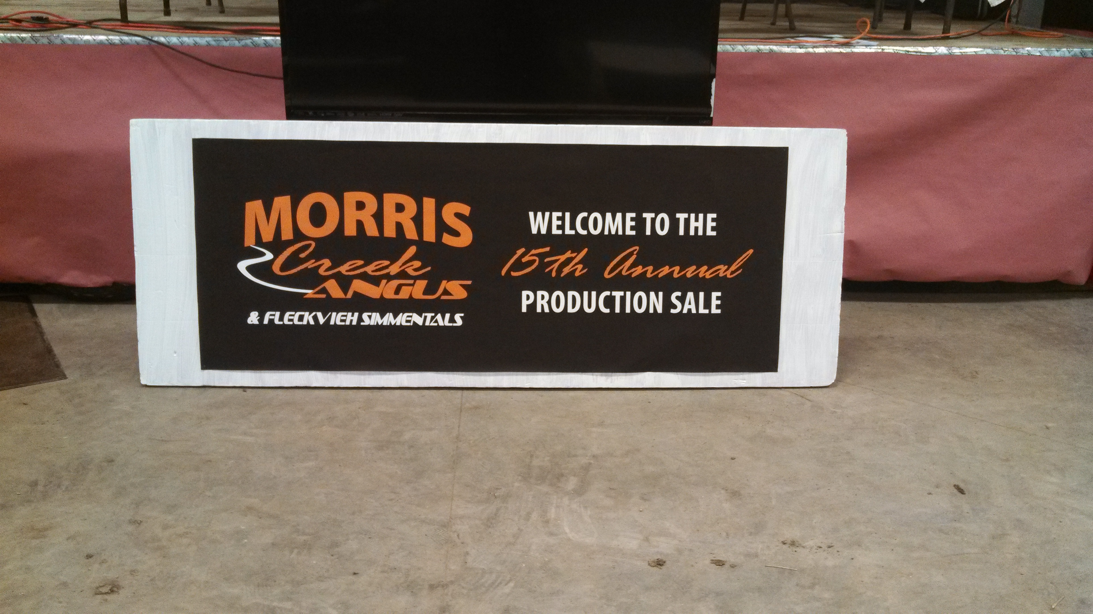

MORRIS CREEK ANGUS 15TH ANNUAL PRODUCTION SALE
Mt. Vernon, SD March 12, 2014

GROSS: $304,550

29 Bulls Avg $3500
61 Bred Heifers Avg $2446
36 Bred Cows Avg $2079

TOP BULLS:
Lot 203s - $7000 MCAS Hackenberg 32
A 6-8-12 son of DFS Hackenberg. Sold to Darrell Marcischuk, Sandy Lake, Manitoba Canada.

Lot 239 - $6250 MCA X-cellency Z209
A 5-28-12 son of OCC X-cellency 614X. Sold to Lenny Boyd, Plankinton, SD.

Lot 230 - $5500 MCA Bando Z674
A 5-22-12 son of RCL Barb 897. Sold to Lonny Jensen, Sanborn, MN.

Lot 3132 - $5000 MCA Final Answer Boy A132
A 2-8-13 son of SAV Final Answer 0035. Sold to Dr. Jim Beatty, Mitchell, SD.

Lot 242 - $4500 MCA Jetset Z567
A 6-2-12 son of Duff Jetset 7122. Sold to Randy Morgan, Letcher, SD.

Lot 206s - $4500 MCAS Red Zaro 022A
A 4-3-12 son of DS Xugo X22. Sold to Curtis Meier, Arlington, SD.

TOP COMMERCIAL BRED FEMALES:
Lot 284A - $3200
Sold to Bussmus Angus, Mitchell, SD

Lot 299A - $3200
Sold to Bussmus Angus, Mitchell, SD

Volume Bull Buyers: Steve Neuarth, Wolsey, SD
Leon Boomsma, Wessington Springs, SD
Jeremy Johnson, Plankinton, SD

Volume Female Buyers: Doyle & Lorie DeJong, Box Elder, SD
Mike Schoenfelder, Mt. Vernon, SD
Justin Dikoff, Faulkton, SD
Steve Huber, Conde, SD
Dale Mack, Castlewood, SD

Auctioneer: Col. Al Conover, Baxter, IA

Sale Manager: Conover Auction Service Inc., Al & Jeanne Conover, Baxter, IA

